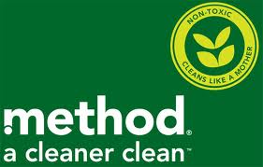

Method Advertising Campaign

By: Kyle Digiantonio, Jesse Novy
& Brielle Weverstad

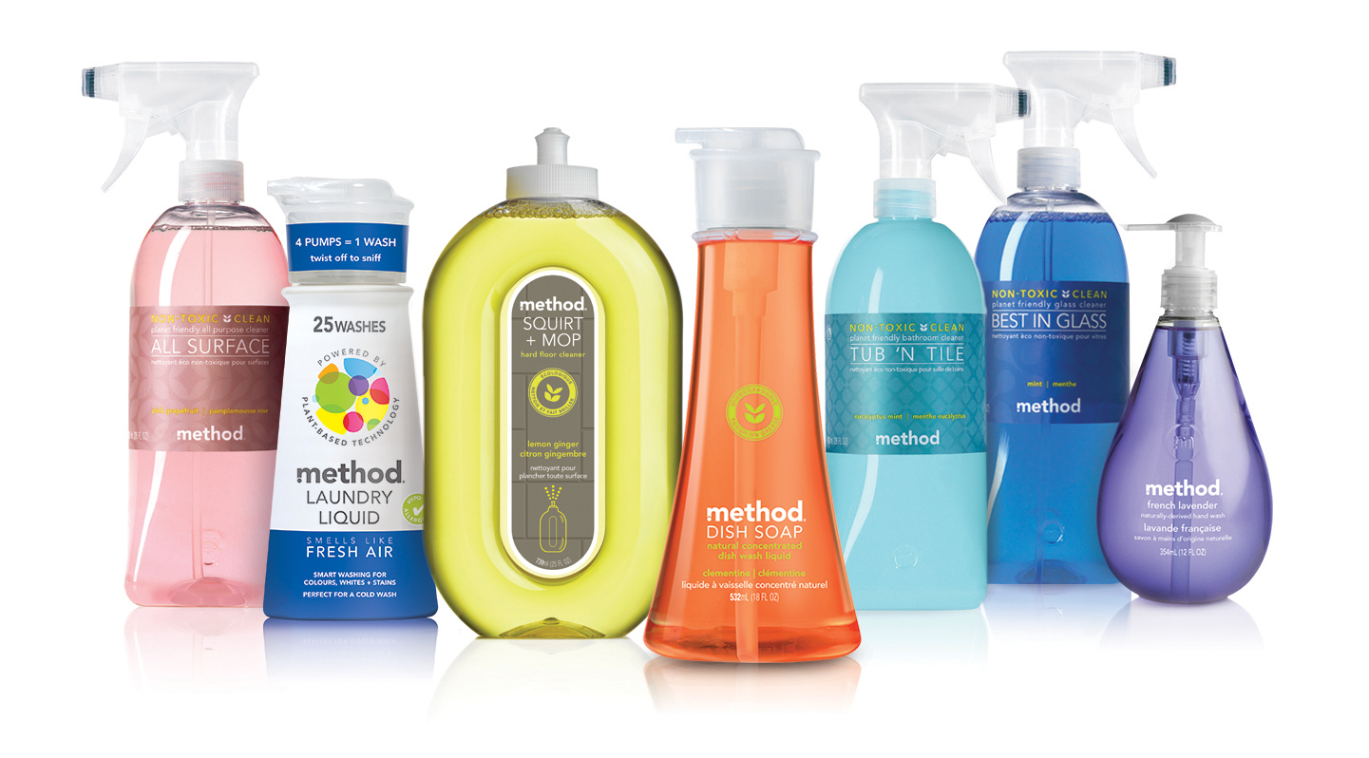
Table of Contents
Selling Idea……………………………………………………………………3

Taglines………………………………………………………………………...3

Print Ad………………………………………………………………………...4

Out of Home/Support Ad……………………………………………….5

Radio Ad……………………………………………………………………….6

TV Commercial……………………………………………………………...8

New Media…………………………………………………………………...11
Selling Idea
We are going to use an old, bitter, crotchety Mother Nature to show Method cleaning supplies as an all natural, eco-friendly cleaner that works just as effectively as harsh chemical products.
Taglines
A bright clean for a bright future
Clean
- A clean nature will approve of
- Modern. Eco-Friendly. Clean
- A fun way to clean
- A fun spin on clean
- A vibrant clean you can be proud of
- For modern clean, ditch the bleach
- A vibrant clean you can see
- Bright clean, bright future
- A clean footprint
- No germs, no footprint
- Save the rigor, clean with vigor
- A stylish clean
- An exciting way to clean
Natural/Nature
- Natural, Effective, Clean
- A natural clean you can smell
- Nature’s fight against germs
- Pure Clean, Pure Nature
- For a natural clean, ditch the bleach
- Modern, Naturally Effective
- A clean nature will thank you for
- Love they nature
- Nature’s cure for germs
- No germs, no landfills, all natural
Green
- Green, the color of clean
- Green, the color of a new clean
- Green, the color of a new way to clean

Print Ad (Magazine)
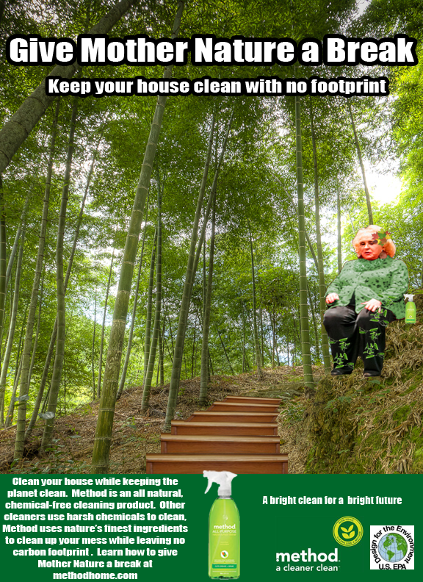
The ad is titled “Stairway to Nature” and is of Mother Nature taking a break after cleaning up some dirty steps. The ad follows the “Z” format where the audience starts with reading the headline and sub-headline, their attention is then drawn to the illustration where Mother Nature is sitting there tired after cleaning some very dirty stairs. The audience is then lead to the body copy with a visual representation of the product, ending with a call to action. At the tail end of the “Z” the tagline, method logo and the designed for the environment logo are situated.
Out of Home/Support Ad
The out of home advertisements will appear in a variety of different places. We will have billboards, bulletins and junior bulletins throughout high traffic areas. In metropolitan and suburban areas we will have transit ads running their routes to help increase the frequency of the ads. We will also incorporate reverse graffiti to help our goal; the reverse graffiti will fit nicely with Method’s message of a natural effective cleaner. The billboards and transit ads will keep in theme of the overall campaign, featuring Mother Nature and discussing how Method benefits both your house and the environment. An example of a transit ad or billboard follows.

Radio Ad
Method
“Meet Mother Nature”
: 60 Radio

Format: Situation

SFX: SPRAY ONTO COUNTER/WIPES COUNTER

MOTHER NATURE: What the devil are you doing? You’re killing me.

BETH: Excuse me? Who are you?

MOTHER NATURE: I’m Mother Nature, and you’re doing that all wrong! All you kids do is take advantage and walk all over me, and I’m done being Mrs. Nice Nature! All of those toxic chemicals have to end up somewhere. Think about it. Whenever you clean your bathroom, think of how dry your hands get and how it burns your lungs! Why do that to yourself? Why do that to ME?

BETH: But I have to clean my house!

MOTHER NATURE: Don’t give me that. It’s not that hard to buy planet friendly products.

BETH: But none of it works!

MOTHER NATURE: Then you haven’t tried Method. It doesn’t use harsh chemicals to clean. It’s made from nature, for nature, so both of us can be happy.

SFX: MAGIC TWINKLING SOUND AS BOTTLE APPEARS

BETH: And it’s colorful!

MOTHER NATURE: Not only that but it smells great! Would you rather have your counter smell like bleach or oranges?

BETH: I guess oranges.

MOTHER NATURE: Then go pick some up already!

SFX: SWOOP

ANNCR: Method: A bright clean for a brighter future!

Radio Ad cont.

The radio ad for Method will reach our target most effectively when played on Spotify, Pandora, or other online radio sites. The ads works because it keeps in line with Mother Nature being cranky and tired of dealing with people using cleaning products that harm themselves and the environment. In the radio commercial Mother Nature is angry with Beth for being ignorant to the environment. Because of this, Mother Nature is sassy and short tempered with Beth. The ad has humor to it because Mother Nature is playing a reverse role.
TV Commercial
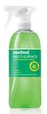
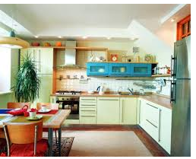
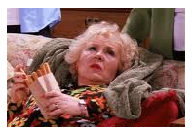
9.END CARD: Tagline Call to action ANNCR: “A BRIGHT CLEAN FOR A BRIGHT FUTURE.” “FIND METHOD AT YOUR LOCAL TARGET STORE.”

8. Susan uses Method and sun shines through the window

SFX: Birds chirping

7. Mother Nature walks to the cupboard and knocks over the generic brand bottles
Mother Nature: “Here, do me a favor for once and use Method.”

6. A confused Susan looks at Mother Nature.
“What do you want me to do?”

5. Mother Nature crosses her arms.
MOTHER NATURE: “You are burying me in my grave.”

3. SFX:Hyperventilation
A disturbed Mother Nature wakes up

4.Susan reaches for chemicals in the cupboard
SUSAN: “This is all I could find at the store.”

2.Susan scrubs the Kitchen counter
SFX Susan Moans

1.Quick shot of a stormy sky with lightning and thunder.

TV Commercial Script
Method
“A Bright Clean for a Bright Future”
Copy Writer: Kyle Digiantonio
Format: Slice Method is the hero
One-liner: Disgruntled Mother Nature tries to rest

VIDEO (CAPS) | AUDIO (Sentence case)
FADE IN:  STORMY WEATHER  SUSAN TIRELESSLY SCRUBBING THE KITCHEN COUNTER WITH RUNNY RED EYES.  TIRED MOTHER NATURE IS SITTING IN A RECLINING CHAIR TRYING TO SLEEP.  SUSAN SCRUBS HARDER FOLLOWED BY HER PULLING HER CLOVES OFF.  A DISTURBED MOTHER NATURE WAKES UP.  SUSAN THROWS HER GLOVES IN THE SINK.  SUSAN THROWS THE EMPTY BOTTLE OF CLEANER IN THE TRASH.  SUSAN WALKS OVER TO THE CUPBOARD AND STARES AT GENERIC CLEANING PRODUCTS.  SUSAN REACHES FOR A CLOROX SHAPED BOTTLE.  MOTHER NATURE CROSSES HER ARMS.  A CONFUSED SUSAN TURNS TO MOTHER NATURE.  MOTHER NATURE GETS UP AND WALKS TO THE CUPBOARD. AND PUSHES THE GENERIC BRAND BOTTLES OUT OF THE WAY.  MOTHER NATURE HANDS SUSAN A METHOD BOTTLE AND GOES BACK TO HER CHAIR.  SUSAN BEGINS TO USE METHOD. SUNLIGHT SHINES INTO THE WINDOW.  END CARD: MOTHER NATURE SITTING IN HER RECLINER WITH A METHOD BOTTLE IN FRONT OF HER. | SFX: THUNDER AND LIGHTNING  SUSAN: I cannot stand this anymore.  MOTHER NATURE: Hyperventilating in her sleep in a reclining chair.  MOTHER NATURE: Hyperventilating and tossing and turning.  SUSAN: I wish there was an easier and less harmful way to clean.  MOTHER NATURE: (In a cranky voice) I am getting too old for this.  MOTHER NATURE: Moans in despair.  MOTHER NATURE: (Exhaling) Why do you continuously torment me with all those harsh chemicals?  SUSAN: This is all I could find at the store.  MOTHER NATURE: (sarcastic voice) I give up you’re burying me in my grave!  SUSAN: What do you want me to do?  MOTHER NATURE: Here, do me a favor for once and use Method.  MOTHER NATURE: Method works just as well, but it won’t harm your skin or the environment.  SFX: BIRDS CHIRPING IN THE BACKGROUND.  ANNCR: “A BRIGHT CLEAN FOR A BRIGHT FUTURE.” FIND METHOD AT YOUR LOCAL TARGET STORE.

This TV commercial works because it follows the selling idea, featuring the reoccurring character Mother Nature, is too old and tired to handle cleaning products with harmful chemicals anymore. She has become grumpy over the years from all the abuse. Method is introduced as the hero to save Mother Nature from chemicals that harm skin and the environment. This TV ad tells a story. The ad uses the same character, Doris Roberts from the print, radio, and billboard as Mother Nature.
New Media

The banner ad will appear on websites such as Facebook, Twitter, Instagram and Target to reach the target audience of women who are 25-32 years of age. The banner ad captures attention by using bold text that reads “Don’t anger Mother Nature.” The banner ad also features the Method products so that the consumer can be aware of their fun shapes and colors. The ad urges consumers to click through to the website, where they can discover more information about the products fun designs and eco-friendly aspects. The banner ad captures the audience’s attention by using the spunky reoccuring Mother Nature character.

